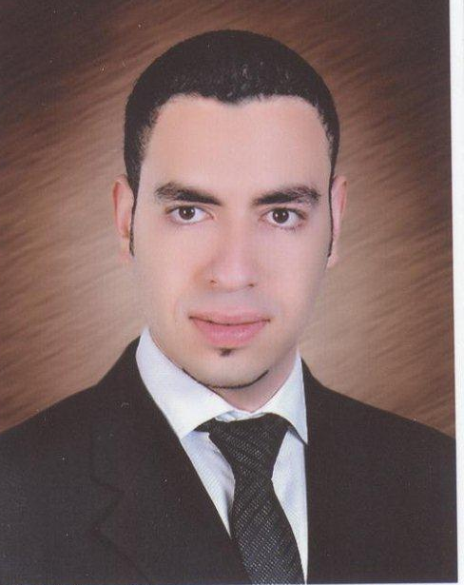
Acc. Amr Metwally Omar
17 Khaled Hassan st. Off Cournish El Maadi, Cairo, Egypt
E- Mail: amr.metwallyomar@hotmail.com
Telephone: (+202) (25898242)
Mobile: (+2) (01000786010)

Objective:

ــTo develop my self capable of adding value and creating a positive impact on business results of my organization in a growing and changing global marketplace.


Professional Experience:

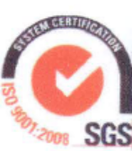
Full Time Job History:

Emarat Misr, Multinational Oil & Gas Co.
From 9/2009 till Now.
Position: G/L & A/P Controller.
Description:

- Follow up and handle all General Ledger and Accounts Payable transactions via ERP Solutions PDI (Professional Data Inc. An American ERP Solution) along with implementation of Business

Solution G/P (Microsoft Dynamics Great Plains).
- Monitor the white products "Gasoline" withdrawals & payments

for EGPC (Egyptian public petroleum corporation) for our
service fuel stations.

- Monitor Aviation transactions either domestic or international flights and Jet A1 withdrawals, procurement and payments for EGPC and other petroleum companies.
- Monitor Marine transactions and Bunker fuel withdrawals and payments for EGPC.
- Monitor contractors, subcontractors and material supplier transactions for monthly billings and tracking actual costs relative to bids as the project develops for construction of our new Stations.
- Monitor the L/G and L/Cs for the imported additives for our unique industrial oil to Packed and Bulk lubes.
- Sharing in preparation of the Financial Statements (Balance Sheet, Income statement, Statement of Owners Equity, Statement of Cash Flow) at closing times.
- Prepare the form 19, 21 and 22 for each at EGPC and Ministry Of Supply and Trade.
- Follow up the Insurance for our property, plant and equipment.
- Auditing the Banks Accounts and Review bank Reconciliations at the end of each
month across several banks and currencies.
- Preparing the monthly financial Closing and reports to my senior managers.
- Preparing the reports relating to the TAX Inspection for my company.
- Ensuring accuracy of accounts and their full reconciliation into the general ledger.
- Generating the general ledger reports at closing time.
- Allocating expenses between the various cost centers.
- Responsible for all phases of accounts payable processing including auditing and processing invoices and payment requisition and accounts payable records.
- General ledger maintenance and analysis, significant elements of the month end process, and internal reporting within the organization.
- Responsibilities include the month end closing/accruals, financial analysis, cost allocations and monthly transactions analysis.

- Monitor and review accounting and related system reports for accuracy and completeness and resolve accounting discrepancies.
- Interact with internal and external auditors in completing audits.
- Verifies or codes accounts ensuring accuracy of cost centers and/or internal orders, as per chart of accounts and Manage Fixed Asset register.
- Coordination with Accounts team. Participates in regular Accounts meetings to keep abreast with all issues relating to the Finance. Discusses and reviews opportunities for the optimization of assigned work programs.

Indevco Group.Sanita Nile Co. International Corporation for Industrial Development and Trading. From 6/2008 Till 8/2009.

Position :Senior Accountant for A/R.
Description :

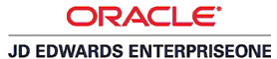
- Follow up and dealing with all Accounts Receivables transactions
on the Business Solutions Oracle Financials (JD EDWARDS).
- Follow up the Credit Notes of Returns for the sold invoices.
-Follow up and review the deduction's advices received from Customers that
relate to their contracts such as "Trade Loader, Volume Rebates, Gondolas Fees, Light Boxes, Listing Fees and Shelf Rent Fees) and make Credit notes and Debit notes to Reconcile that.
- Follow up The legal file for the whole customers in coordination with admin. dep.
- Prepare the AGING Reports according to Credit Limits and Credit Periods for each customer two times a month.
-Evaluate customers into Good and solvent, Low risk, Medium risk and High risk customers, consequently we set credit limit and aging number of days.
- Review of accounts receivable lists and evaluate Bad Debts risk.
- Prepare the Aging Balance Confirmation for whole customers (Institution Dep., Key account Dep., Whole Sales Dep. and Distributors) on monthly basis with the original copy received by the accounts dep.of each company not later than the 15th of the following month.
-Determine the net sales and collection for each customer and department then make
The Ratios and Charts Reports, in addition to the aging number of days by sector (Actual vs. Target) Reports and present proposals in the periodic Credit Committee Meetings.
-I'm working in assisting the sales and collection managers in analysis of their
operation performance.
-Prepare the relating Receivable Reports to my senior managers.


Cairo News Co. Multinational Company for News Media,
Broadcasting & Telecom. From 1/2006 Till 5/2008.

Position :Senior Accountant for G/L.
Description:

- Bookkeeping (American Journal, Ledger accounts) and posting these accounts to
The Trial Balance.
- Keeping the vendors' accounts, account payables&accrual accounts & working
to pay these credit accounts in specific schedules. All of these accounts by books
besides the ERP Solutions Oracle Financials (AL MOTAKAMEL) (OFS-SOFT).

- Prepare payables reports, review outstanding payables, prioritize payments and ensure all necessary codlings, checking and authorizations are carried out.
-Reconcile supplier accounts of Satellites (Nile Sat, Arab Sat, Eutel Sat, IHA) and
ensure the accuracy of Service Performance.
-Follow up other creditor and accruals accounts in accounting system.
- Sharing in preparation of the accounting CHART of the oracle financial ERP.

-Verification between Sub-Balances with Main Trial Balance and find out the
discrepancies between them.
- Monitor and review the cost accounts of our clients, temporary down payment and petty cash. Prepare the "41" FORM for Withholding tax quarterly.
- Interact with internal and external auditors in completing audits.
- Keeping the accounts receivable and making clients invoices and send them through
UPS such as (French TV- F2-F24, Lebanon TV – LBC , USA TV- CNN, IRAQ TV).
-Sharing the preparation and establishment of the ( Beeaty TV) in Media City.
- Supervision the major operation for Aljazeera TV JSC and MEN at Arab League
and Presidency Palace for important events.

Alfa Plus Co. For Digital Satellite Systems. From 2/2004 Till 12/2005.
Position :General Accountant .
Description :

- Bookkeeping (American Journal, Ledger accounts) and posting these accounts to
the Trial Balance. Keeping the vendors' accounts and account payables.
- Making daily accounting activities and entries by the ERP Solution
Oracle Financials (ALMOTAMMEM) (OFS-SOFT).
-Prepares asset, liability, and capital account entries by compiling and analyzing account information.
-Documents financial transactions by entering account information.
-Reconciles financial discrepancies by collecting and analyzing account information.
-Secures financial information by completing data base backups.
-Prepares payments by verifying documentation, and requesting disbursements.

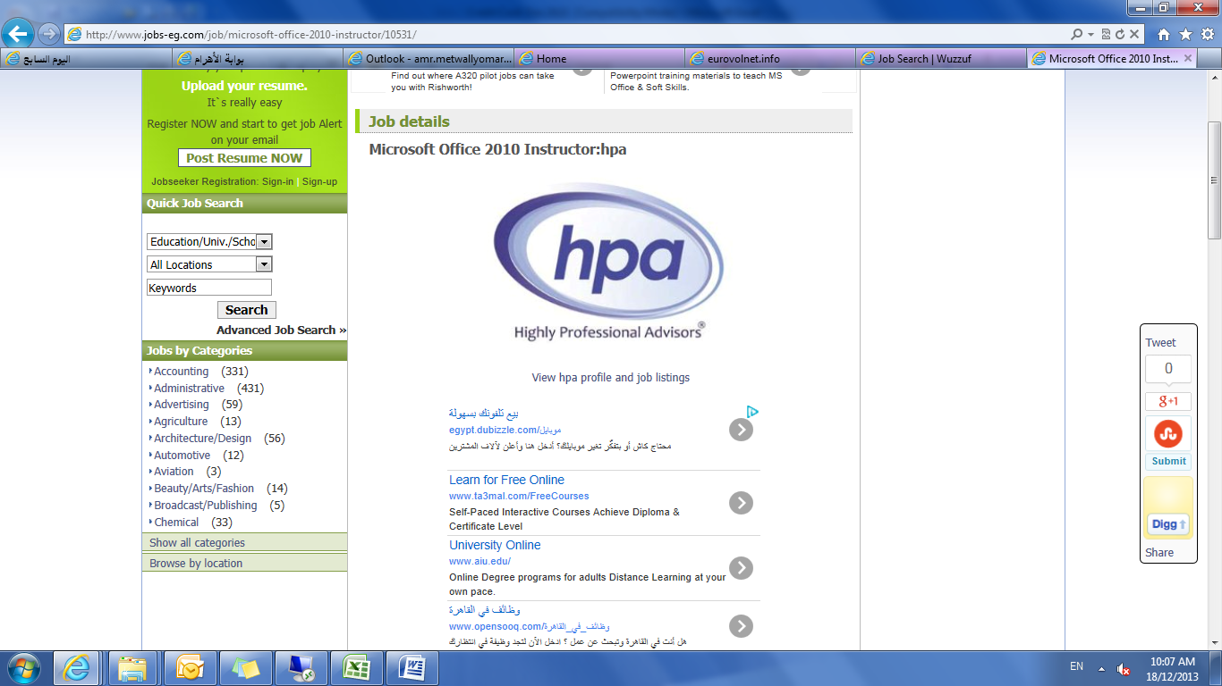
Part Time Job:

Highly Professional Advisors. Current.
Position: Financial Accounting Trainer & Instructor.
Description:
- Based on my wide knowledge and experience in Finance and Accounting modules and practices in reality of business life and also my talent of teaching, consequently I’ve the ability to achieve expertise by education measures, motivate participants to be active lifelong, impart fun and well-being, instruct the participants the right way and on the appropriate level, create a binding among the participants.

Education:
Post Graduate Studies:
- I am studying CMA (Certified Management Accountant).
At first I was studding at IPA (Institute Of Professional Accountants) after that I am continuing studding self-study.


- Certificate in EAS (Egyptian Accounting Standard) in comparable
to IAS and IFRS from ESAA in Cooperation with KPMG,
Earnst &Young and PWC. May 2012.
Certificate Outline:


To develop a single set of high quality, understandable,

enforceable and globally accepted Egyptian and international financial
reporting standards through its standard-setting body, to promote
the use and rigorous application of those standards, to take account
of the financial reporting needs of emerging economies and medium and
Huge-sized entities, and to bring about convergence of national
accounting standards, IAS and IFRSs to high quality solutions

- Certificate in "Valuation of Assets" from AUC (The American University

In Cairo) June 2011.
Certificate Outline:
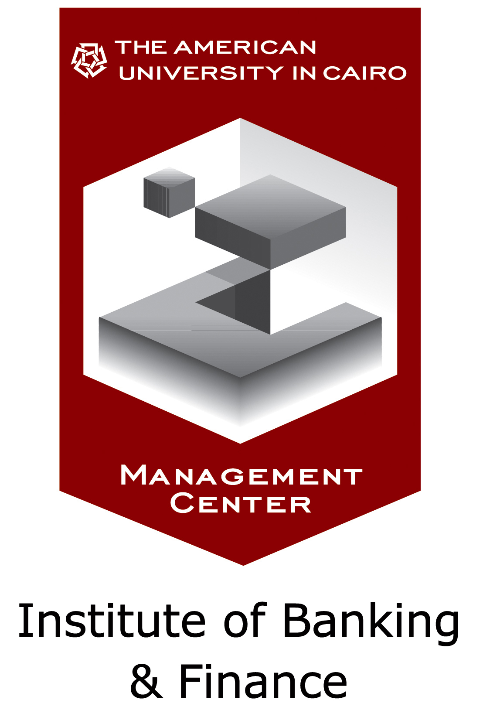
This certificate was enabled me to understand in depth the fundamentals of project analysis, finance and Valuation Methods (Income Based & Asset Based), Annuity vs. Perpetuity. It also gave me the chance to discuss in details the concept of restructuring and the optimal capital structure, cost of capital, Value of money FV PV, Compounding & Discounting, Capital Budgeting, Appropriate discount rate (sources of capital) ( cost of debt, preferred stock , common stock). And maximizing the value of the firm.


- Certificate in "Financial Management "from AmCham (American Chamber Of Commerce) Nov. 2010.
Certificate Outline:
The Investment Setting, the Asset Allocation Decision,
Introduction to Portfolio Management, Investment Objectives and Constraints, Risk associated with Investment in a Global Market, Credit Risk Approaches, and Centralization and defining different bank’s roles in finance.

- Certificate in "Financial Analysis" from AmCham (American Chamber Of Commerce) July 2010.
Certificate Outline:
Ratio cross sectional analysis, Liquidity analysis, Activity analysis, Leverage analysis, Profitability analysis, Horizontal analysis, Vertical analysis, evaluating financial risk and in- depth analysis of a company’s financial statement.

- Certificate in "Financial Accounting and Reporting" from IPA (Institute Of Professional Accountants) May 2009.
Certificate Outline:
External financial reporting, Cash and receivables, Inventories and
investments, Long-Lived assets, Liabilities, Equity and revenue recognition.

University Study:

- Faculty of Commerce Ain Shams University Egypt Major Accounting.
- Date of graduation: May 2003.

Courses:
- American language courses at Ministry of Defense Language Institute (I was Passed the Advanced and Conversational levels with grade Excellent.
- Computer courses Windows, Office and Internet at TIC (Trade Information center).

Practical Skills:
Computer Skills:
-Excellent Usage of the ERP Solutions, BUSINESS and ORACLE Financials
such as (JD Edwards, G/P, PDI, AL MOTAKAMEL and ALMOTAMMEM).
- Excellent Usage of Microsoft Windows all editions.
- Excellent Usage of Office Applications (Word, Access, Excel, Power point).
- Excellent Usage of Internet.

Language Skills:
- Native Language Arabic. - Very good command of both written and spoken English.

Effective Skills:

- Well familiar with accounting theory, GAAP, IFRS, IAS, EAS and practical its application to various accounting transactions and problems.
- Excellent organizational, Communications and time management Skills.
- Ability to self-manage and influence others to meet commitments.
- Ability to take responsibilities and ownership for tasks and to use initiatives.
- Able to work effectively, efficiently and with a positive attitude.
- Self-motivated and able to work both independently and on a team.
- have a passion for challenges, continuous improvement, excellence and integrity.
- Ability to make fast and yet reliable decisions about problem solving.
- I’m energetic, enthusiastic, dynamic, persuasive and hard working.
- Best dealing with my Direct Subordinates, colleagues and bosses.

Memberships:

Record of Chartered Accountants & Auditors Member:
- I hold the Record of Chartered Accountants & Auditors Number R.C.C. 25776.

Syndicate of Commercial Professions Member:
- I hold The Syndicate Member Number 07/391/03 Accountants & Auditors
Department.

Honors & Awards:
- Emarat Misr's 2010, 2011, 2012 Thanks Letter for outstanding Performance.
- Indevco Group's 2009 Certificate of Excellence of the Year.

Hobbies:
Reading, sports, internet, looking for what's new at each field.

Personal information:

- Birth Date : 21 March, 1982. - Gender : Male.
- Marital Status : Married. - Nationality : Egyptian. - Residency : Cairo, Egypt. - Military Service : Exempted.

