Mohamed Ahmed Zaki Fahim, PMP &PMC
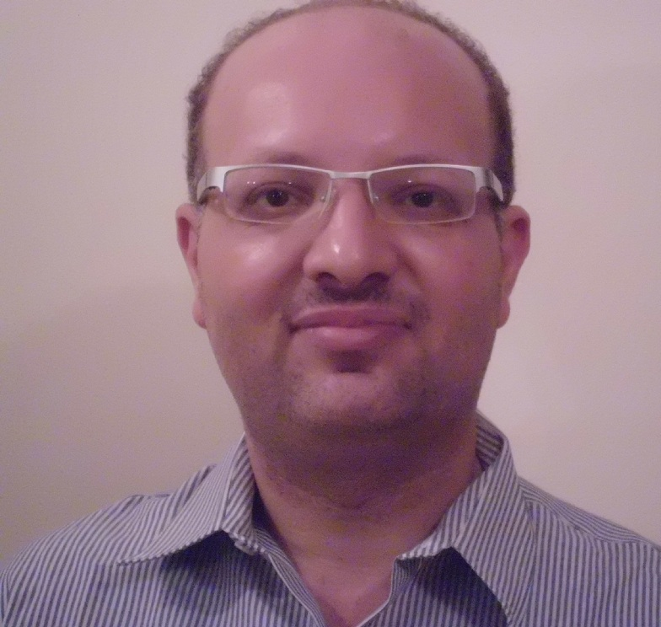
Email: mohfahim1974@gmail.com
25 Dr Ahmed Zaki Street New Nozha
Cairo, Egypt
Cell Pone:00201007606548
Residence:0020226221281
USA-UK Educated
Project Management Specialties
Education Technology –Media –National Projects-
Telecommunication- E-Learning- ERP
U.S.A Graduated from National American University in Kansas Rapid City IT Certified PMP,PMC with a total of 12 years of experience in which spent 9 years experience in Projects Management in various industries ( Educational Technology - Media-National Projects –Telecommunication-E-learning –ERP – Cryptography) ,Software QA/AC Analyst/Programmer /DBA/ERP /Web designer/Java2jdk 1.3 IT Instructor Professional Compensated with other 3 years experience in Oracle 8i/9i and Developer2000 using Unix/NT/XP Platforms Operating systems . I’m confident, responsible, hard working and have always been a keen and dependable person in work. Finish given tasks well before time and always excel in job assigned to me .Always In search of challenging projects with flair to learn new things and along with my Experience, reaching out new perspectives in life. Core Business Competence includes :
Project Management | Financial Management | Integration Management
Change Management | Communication Management | Quality Management
Risk Management | Resource Management | Scope Management
Client Relation | Business Analysis | Time Management
Strategic Business Planning | Procurement Management | Contingency Plan

Professional Experience

Hired at Informatique on contract duration from Oct 2012 Till May2013 Cairo, Egypt. Managing two Fast Tracking projects .
Position Holding : Education Technology Projects Manager using PM Methodology (CMMI Level 3)
1. Responsible for managing projects, in order to achieve organization business objectives within established budget, schedule, quality standards and targets, all over project' life cycle.
2. Prepare all Project plans as Informatique quality management system
3. Review and tune the project planned tasks and effort
4. Monitoring , follow up , and control project execution and issues project periodical reports progress
5. monitoring Project deliverables within Informatique standards and financial status
6. manage projects risks
7. Monitor and control Change Management
8. Project closer and update project reports

Hired at MBC Group Media from July 2010 to June2012Position Holding : Media Projects Manager PM Methodology ( Scrum Agile) Cairo, Egypt
1.As a media Project Manager I do report to an Operational Manager who is located at Dubai United Arab Emirates . My responsibility as a media project Manager as a Cross Dispensary by Gather Requirements from Dubai Team and then pass it to Technical team to work on it as well communicate Globally with Dubai Team to complete work packages .
2.. Types of projects that I’m working on they are commercials, Channels and Competitions .
3.Sprint Review meetings , We do have on daily basis scrum meetings which consists up of Project Manager, Operation Manager ,Account Managers ,Creative Manager ,Technical Manager , Quality Manager and Planning Manager or a Delicate . The main of the meeting to review issues that raised , Review the progress and project outstanding.
3.Projects Backlog : The project sprints are set in the backlog with priories for delivering each sprint , there is possibility that priorities among sprint are changed based on Client Approved change request but it should be in between specified time box . That it ranges between 1 to 2 weeks .
4.Lead MBC3 Eish Safaria Islands : The main scope of project was to build a game community that enables worldwide children to communicate through chatting and getting introduced to each other with the side to side moderators and super moderators are monitoring and controlling chat . I and team we had reformed the project from Conception – Design – Development – QA/QC – Closure – Roll OUT.

Hired at UNDP Appointed at Ministry of Department State for Administrative development
From 03/01/2010 To 31/07/2010
Position Holding: Projects Manager - National ERP Projects
- Lead a team consisting of three project Manager reports ,2 Developers , 1 Quality Control and 2 Technical Supports .
.
- As a Projects Manager I do report to Head Planning and strategic Sector Manager
- Planned ,Presented and Organized Kenya Embassy Asset Management Integrated with ERP Management and awarded with A thanking letter from Kenya embassy and from MSAD International Public Relation.
- Key communicator with OECD for presenting National Egyptian Procurement
Orascom Link Dot Net from 01/07/07 to 31-12-2009 Cairo , Egypt
Position Held: Telco Project Manager - Telecommunication Industry
1.Handled Projects of Family Products that consisted up of (DSL – Leased Lines – Wi-Fi Café’s – Mob nil SMS & Entrepreneur a large and Medium Projects.
2. Managed a Continuous Improvement by releasing a n updated Version 2 of Tracer.
3. 90% Horizontally Communication with external stakeholders (Customers) and internal Stakeholders of project (Team).
4. 50% Meeting with all Stake holders that are concerned with the project.
5. Implemented a new work flow strategy through an appropriate pathway of a product life cycle.
Binary Works from 14March 2006 to 14 June 2007 Cairo , Egypt
Position Held ; E- Learning Projects Manager
1.Establish project 90% communication with Account Manager who acts as a representative to direct customer, collecting customer requirements and communicate it back to me through a drafted statement of work document till we finalized the business scope.

2.Prepare all Project plans as per Binary Works quality management system

3.Review & Evaluate RFP’s & RFQ’s from Bids that are brought by Account
Manager.
4.Build Scope Management Plan after defining scope with Stakeholders.
5. During project initiation stage till closure phase I document each project stage that is undertaken through Microsoft schedule plan with duration set and effort sizing of each Resource allocated on project .

Egyptian Saudi Group from Jan 2004 up to Dec 2005 Cairo, Egypt
Position Held : ERP Projects Manager
- Carried out a water fall methodology through an end to end project life cycle, I had initiated project with direct customers after project is being brought up by sales Manager.

- During project Initiation , I document all the customer requirements through a round table meeting , by then I document all those requirements into a preliminary statement of work and forward to the customer for their review and conformity and after the customer finalize the business scope of his needs.

3.During Project Plan, I arrange for a kick off meeting along with the team to build a project plan that constitutes up of a scope management plan , communication management plan , risk management plan, Quality Management Plan , Human Resource Management plan , Project cost Management plan , project procurement management plan and project integration management plan .
4. During Project Execution Plan, I manage the execution plan thus the team members whom they act as internal stakeholders they will execute (Analysis, Design, Development and Implementation) to produce a project deliverable, where the produced deliverables will be allocated to quality control engineer for inspecting and making sure that the produced deliverables it is free of errors.
5.During Project Monitoring & Control Plan, I do confirm that the project life cycle it is under control and it is maintained and that each deliverable produced with a high quality. Through monitoring and control I do confirm that project deliverable are meeting the customer requirements , as well to confirm that project deliverable are produced as planned and that the project is delivered on planned agreed defined dates.
6. During Project Closure plan, I provide the customer with a tested released versioned product for customer acceptance , As well the customer will be provided with a customer acceptance criteria document ,so that once the customer signs off the acceptance document , this means that the project it is successfully delivered .

Kuwait Food Company (Americana)from March 2002 to March 2003 U.A.E , Sharjah
Hired as Oracle 9I & PL/SQL Analyst Programmer
- As an analyst programmer in department of MIS (Back office) where participated In developing new packages for different departments of the organization as By using oracle9i & Developer 2000 for creation of forms and reports

- Complete PL/SQL (procedure and Functions).
- Complete triggers Assigning
- Complete Designing reports.
- Passing report parameter
- Creating Menus.
- Creating LOV’S
- Check Data Consistency.
- Perform Data migration

Unisys –Alghurair Enterprise for Computers from NOV 1998 up to Apr 2000
U.A.E .Dubai
Hired as Oracle 9I & PL/SQL Analyst Programmer Trainee

- By using Developer 2000 package I had developed Interfaces by using a form builder based on tables that I had designed it in database.

- For summary reports to give a statistical analysis to
User I used report builder manual design and not based on
Automated report Wizard such as tubular Matrix and etc.

- A complete coding was used in forms including
(Lov’s, triggers, canvas, passing parameters, nested
Loops such as cursors, procedure and functions).

4.Program tester: As for Rak Municipality project I
Had to perform several tests such as Data Integration,
Data Consistency, Data Query, data insertion.

Educational Qualifications

- Bachelor of Science Information Systems with emphasize of Web Master and Web Developer. National American University U.S.A Kansas
Rapid City. 23Aug2001
- Associate Degree of Applied Science in Information Technology
National American University U.S.A Kansas Rapid City 23 Aug2000.
- Diploma in Business information Systems (U.A.E Dubai) 23Nov2000
- B.Tech in Aerospace Engineering. (U.A.E Dubai) July 1997.

Professional Certificates

- Certified Project Manager Consultant Feb 2010
- Certified Project Manager Professional 1st Nov 2007
- Certificate in Building a Professional & credit Image from DALE CARNEGIE TRAINING 2nd of June 2008

- Informatics Cultural Institute (U.A.E Dubai) Oracle 8i& Developer2000 .June 2000.

- Derby Training Center (UK London) Oracle 8i&Developer2000. 28Aug2000

- Informatics Cultural Institute (U.A.E Dubai) Oracle 8i DBA
28 Aug 2002.

- Informatics Cultural Institute (U.A.E, Dubai) Advanced Web Designing with Java Programming 15 Dec 2000.

- National Institute of Technology (U.A.E, Dubai) Oracle7.0&Developer 2000. 20-Nov1998.

- Oracle 8.0 & Dev2000 Programming from Derby Training Center 28 August 2000.

- Geac, Ernest & Young &Microsoft (U.A.E ,Dubai).

PM Professional Tools

- MS Project 2007
- Mind Manager Ver 6.0
- Mantis Bug Tracking tool
- Fug Bugs
- Jira

Languages

- Fluent Spoken & Written English
- Fluent Spoken & Written Arabic

Driving License
- Holding a U.A.E License no 143247
- Holding a Valid Egyptian License No 2023809
Own a Car in Egypt.
Hobbies
- Research Work
- Prepare Presentations
- Give Presentations
- Discuss New technology
- Exploration of new technology
- Reading

Personal Details

- Date of Birth: 1st of June 1974
- Nationality : Egyptian.
- Marital Status: Married with two children’s
- Military Status: Exempted

